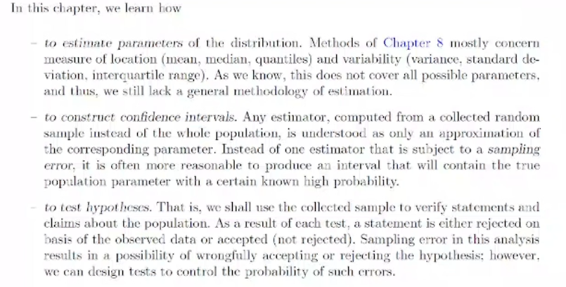

PARAMETER ESTIMATION

Example:

Method of moments:

Shift data to center.

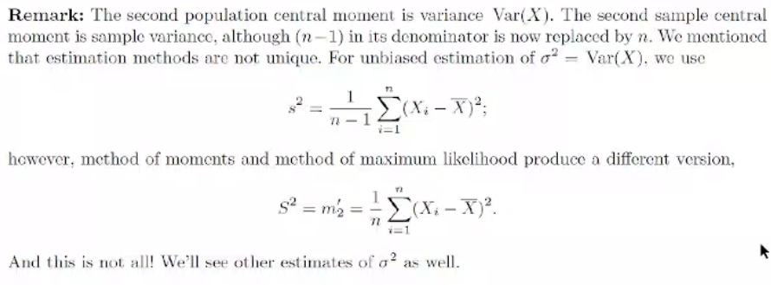

ESTIMATION

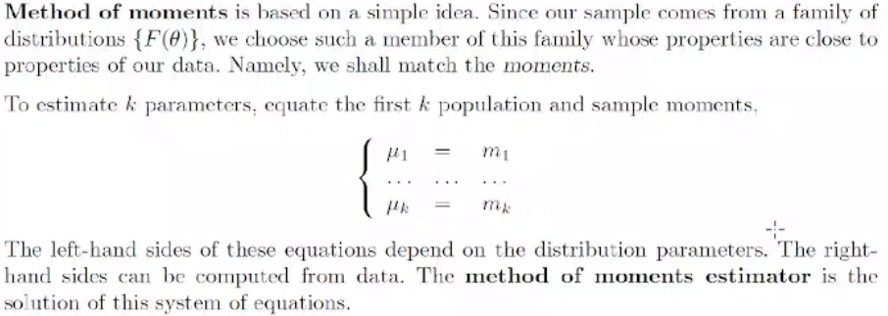

Example:

hat is estimation. Parameter is landa. That’s what we estimate.

Example:

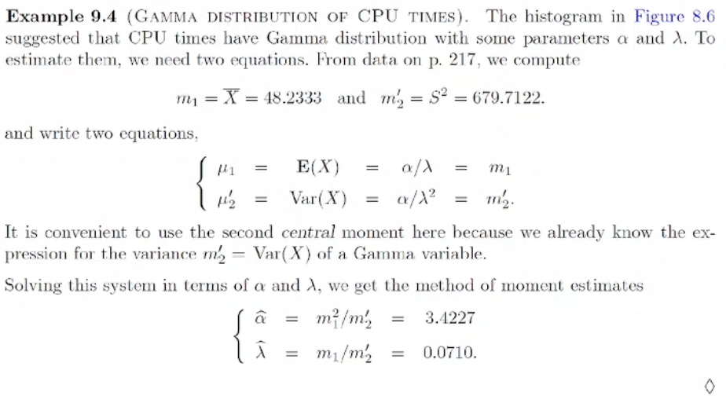

Example:

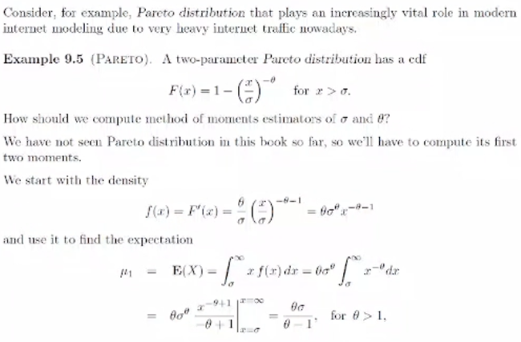

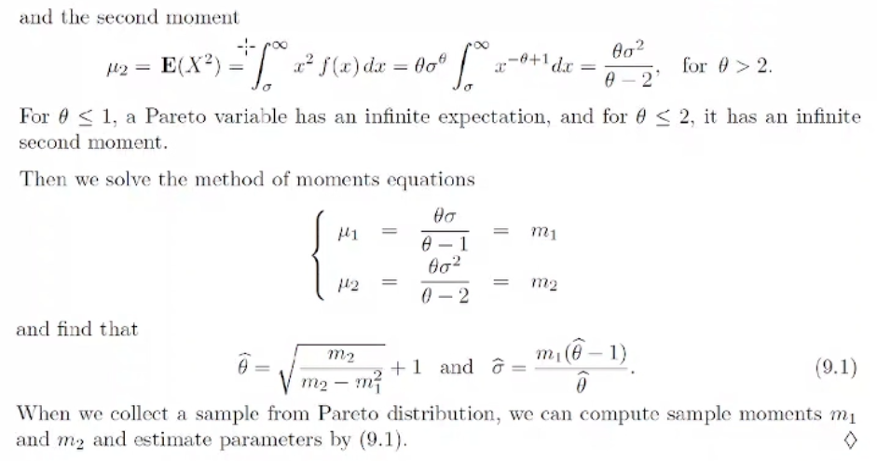

Example:

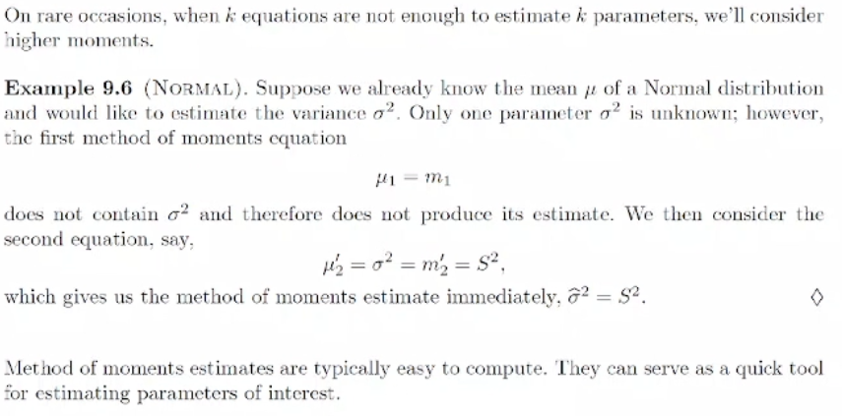

Method of maximum likelihood

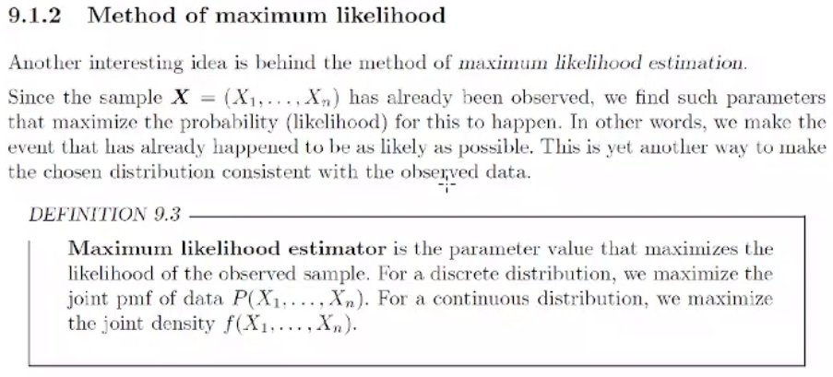

Example:

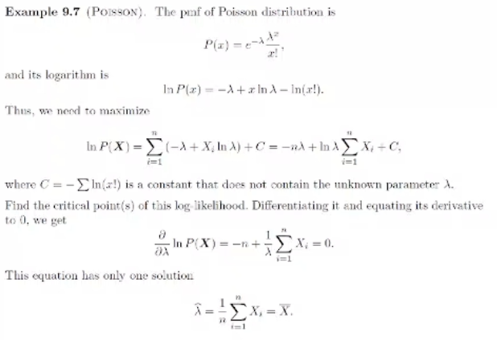

Continuous case:

Example:

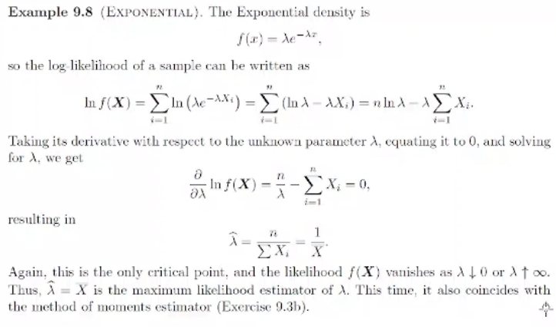

Example:

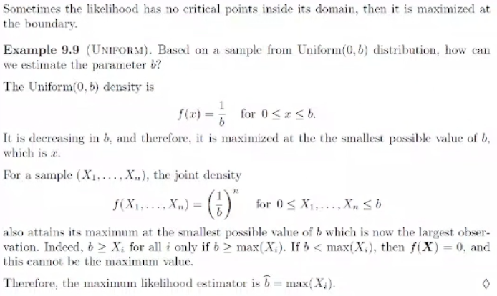

Example:

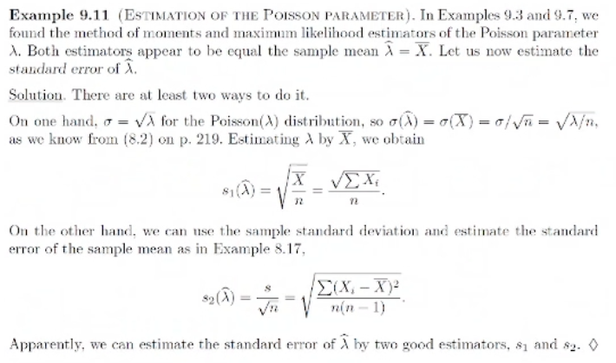

Example:



